Shree Mirambika College Of

Education

FRIEND'S HOTEL

**VIRAJ SOLANKI**

**Under Guidance**

**Of**

**Guide Name**

**Mr.Bharat Mungpara**

**Submitted to the college**

**Shree Mirambika College Of Education-Rajkot**

**In partial fulfilment of the requirement**

**BACHELOR OF COMPUTER APPLICATION (BCA)**

**IN**

**5TH Semester**

**Year of Submission**

**2019-20**

**Saurashtra University Rajkot-360005**

INDEX

|  |  |  |
| --- | --- | --- |
| No. | Description | Page No |
| 1 | Preface | 03 |
| 2 | Declaration | 04 |
| 3 | Acknowledgment | 05 |
| 4 | Project Profile | 06 |
| 5 | Web Architecture | 07 |
| 6 | Web Pages | 08 |
| 7 | Introduction to HTML | 10 |
| 8 | Introduction to CSS | 11 |
| 9 | Introduction To JAVASCRIPT | 12 |
| 10 | Introduction To PHP | 14 |
| 11 | Introduction to MySQL | 17 |
| 12 | Introduction to PHPMyAdmin | 19 |
| 13 | System Requirement | 21 |
| 14 | Fact Finding Techniques | 22 |
| 15 | System Development Life Cycle(SDLC) | 24 |
| 16 | Data Dictionary | 26 |
| 17 | DFD Diagram | 29 |
| 18 | User Panel Web Page | 31 |
| 19 | Admin Panel Web Page | 39 |
| 20 | About Testing | 40 |
| 21 | Bibliography | 41 |
|  |  |  |

**PREFACE**

Practical training is a part of our study in BCA sem 5. It is compulsory for each student to take training for saurastra university.

First of all we would like to say that project is very essential part of our

Educational quota. If we are going only for theory parts, it can not give as

Perfect knowledge.

This project report of Friend’s Hotel. We object in 5th semester in BCA.

This web site is developed for online Indian hotel in room finding and save your time.

For that user must have valid email account like yahoo, Gmail, Hotmail etc.

This web site is quite easy in operating so that any user can able to use it

Easily.

Your co-operation in form of suggestions and comments are most welcome,

To improve any knowledge and project.

“MIRAMBIKA COLLEGE OF EDUCTION”

E-MAIL:- sviraj202@gmail.com

We are pleased to present this report on the project named “**FRIEND’S HOTEL**” developed at the computer lab of the MIRAMBIKA COLLEGE OF EDUCTION RAJKOT. In the year 2019 in our 5th Semester curriculums.

We project contains various details about “**FRIEND’S HOTEL**”. by seeing this project people can gather information about the room facilities. the also contains recipe photos, popular Top room facility andbes food verities. By which people or general public can easily understand our website.

**DECLERETION**

We are student of B.C.A sem-5 hereby declare that the project work presented in this folio is my contribution and have been carried out under supervision of all professors of B.C.A Department of mirambika College of education Rajkot.

The main objective of this training undertaken is to get specialized knowledge in a particular specialized field, which further sharpen the skill and also include that it is a part of our studies undergoing.

This work has not been previously submitted to any other institute/university for any of the purposes.

**Acknowledgment**

The preparation of the report is our own work, but we have taken help from many people. We are thankful to all those persons who helped us in activity out this work.

We express our deepest of gratitude the Project Guide of “MIRAMBIKA COLLEGE OF COMPUTER SCIENCE” and the entire member who provide all the necessary information.

He / She give us great pleasure in thanking who helped us out in our work. Without Him / Her ever ready help, whole hearted guidance, never ending encouragement and enthusiasm. It was difficult to bring this report to its present form.

We thank **Mr.Bharat Mungpara (Project Guide)** before giving us full guidance and cooperation in understanding the system. I also thank them for their unconditional help in making of this project.

We would be failing our duty if we will not mention thanks to family members, relatives and friends to helping us throughout.

Date

Place: Rajkot

Thank You,

Viraj solanki

.

**Project Profile**

**Developed At : -** Mirambika college of Education - Rajkot

**Developed for** **: -** Friend’s Hotel

**Developed By : - VIRAJ SOLANKI**

**Main Pages : -** Home page (Index.php)

**Operating System : -** Microsoft Windows 10.

**Web Server : -** XAMPP1.6.8 &WAMP 2.1

**Web Browser : -** Internet Explorer, Mozilla Firefox,

Google Chrome, Opera.

**Editor : -** Dream Viewer, Notepad ++

**Hardware Requirement**

**For Internet Access : -** 486 D*2 or Higher Processor.

Free Disk Space 100 MB.

Color Monitor & Multimedia Kit.

One Free comport For Modem.

Modem 56 Kbps.

**Guided By : - Mr.Mungpara Bharat**

**Submission At** **: -**BCA Department of;

Mirambika collage of Education.

**Web Architecture**

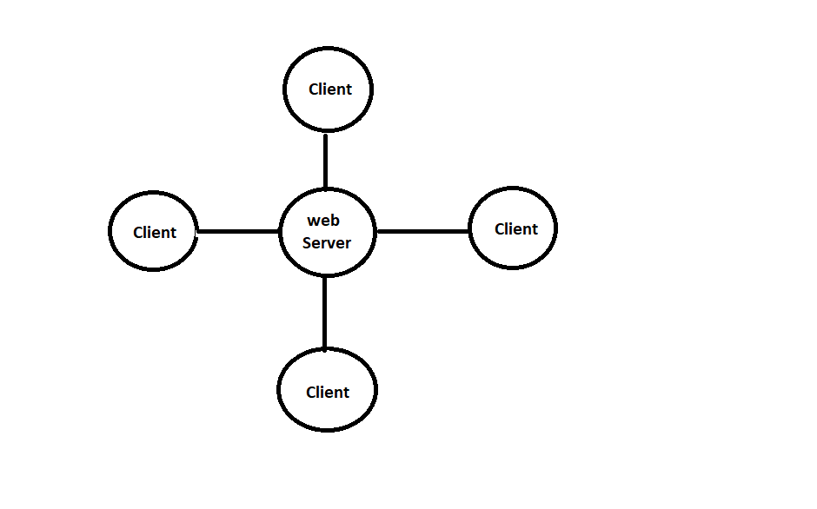

A **Web Server** is a computer that runs the web server software**,** which responds to page requests**.** It is also called **host.** The two main types of web server are **HTTP Server** that follows the HTTP protocol**,** and FTP servers that follow the FTP protocol.

A **Web Client** sends requests for data to a web server**.** When the web server processes the request and sends the requested page to the client (remember the browser is used to view these pages and send requests**.**)

**WEB-PAGES**

The big attraction with active server pages, of course is the ability to include script directly in the file that’s referenced by the browser, and that creates dynamic pages.

It’s important to recognize how ASP differs from existing methods such as refining a static page, executing CGI and ISAPI applications or running traditional scripts.

There are two types of web pages that are as under**:**

1. Static Web Pages

2. Dynamic Web Pages

* **Static Web Pages:**

When the user enters URL into their browser’s address box, or clicks a hyperlink on another page, a request for that page is sent to the server. This is just a file on the server’s hard disk, and the web server software starts by loading it into memory. If it’s a normal static HTML page, the server adds a few transmission protocol requirements such as the document type, encodes it so that it can be transmitted over HTTP, and sends the whole thing to the browser.

The user sees the contents as rendered HTML page, but the same source is the same is the file that is stored on the server’s disk.

* **Dynamic Web Pages :**

To create a dynamic web page using traditional methods, the server has to do more than just package up and send a file from disk. If the request from the browser is for a CGI or ISAPI application file, the server loads application & executes it. The application itself creates a stream of text HTML code, just like if was sending it to a printer. This is assembled in to a temporary page on the server, packaged up for HTTP transition, and sent to the browser. To the user, it looks just like a normal static page, because it’s still just HTML code. However, the actual page is no longer just a copy of the file on the server’s disk. It is created on the fly, and the page can be refreshed. Each time the application that creates it is refreshing.

**Introduction to HTML**

* **Introduction HTML:-**
* HTML Stands for “Hyper Text Mark-up Language”.
* The HTML document Consist of special Tags that are embedded in an ASCII document**.**
* HTML is a simple mark up language used to created hypertext documents that are platform independent.HTML documents are SGML documents with generic semantics that are appropriate for representing information form a wind range of domains.
* HTML markup can represent hypertext news, mail, documentation, and hypermedia; menus of options; database query results; simple structured documents with in-lined graphics; and hypertext views of existing bodies of information.
* HTML has been in use by the World Wide Web(WWW) global information initiative since 1990. This specification roughly corresponds to the capabilities of HTML in common use prior to June 1994.

Web browser like Internet Explorer**,** Netscape Navigator etc., interprets these Tags.

**Introduction to CSS**

* **Definition:-**

CSS stands for “**Cascading Style Sheet"**. CSS are a series of instruments that specify how text should appear on web pages .you can use CSS to set styles for text, font, border, list and background.

* Advantages of CSS**:-**
* **CSS save Time :**

When most of us first learn html, we get taught to set the font ,face, size, color etc. every time is wasted with CSS, you occurs on a page. that time is wasted with CSS you only occurs have to specify these details once for any elements.

* **Pages Load Faster :**

Less code means faster download times.

* **Easy Maintenance :**

To change the style of an element, you have only to make an edit on one place.

**Introduction to JAVASCRIPT**

* **Definition :-**

A Scripting Language for web pages. Scripts written with JavaScript can be embedded into HTML documents. JavaScript is an interpreted language means that scripts executed without preliminary compilation.

* **Introduction :**

JavaScript is Netscape's cross-platform, object-oriented scripting language. JavaScript is a small, lightweight language; it is not useful as a standalone language, but is designed for easy embedding in other products and applications, such as web browsers. Inside a host environment, JavaScript can be connected to the objects of its environment to provide programmatic control over them.

JavaScript can function as both a procedural and an object oriented language. Core JavaScript contains a core set of objects, such as Array, Date, and Math, and a core set of language elements such as operators, control structures, and statements.

* Features of JavaScript**:-**

JavaScript is becoming increasingly important and it remains the osbroadly available scripting language for Web development. The features of java script are as follow**:**

* **Higher-order functions :**

A high-order function is one that either takes functions as arguments or returns a function. This feature lets java script programmers manipulate functions in ways that the Java language can't.

* **Dynamic typing:**

By delaying binding, JavaScript can be more concise and flexible.

* **A flexible object model:**

JavaScript's object model uses a relatively uncommon approach to inheritance called prototypes instead of the Java language's more common class-based object model.

* Advantages of JavaScript**:-**
* JavaScript gives HTML designers programming tools.
* JavaScript can put dynamic text into HTML pages.
* It can react to events.
* It can read and write HTML elements.
* It can be used to validate data.
* It can be used to create cookies.
* It can be used to detect the visitor’s browser.

**Introduction to PHP**

* The full form of PHP is “**Hypertext Pre-processor**”. Its original name was “**Personal Home Page**”.
* Rasmus Lerdorf software engineer, Apache team member is the creator and original driving force behind PHP. The first part of PHP was developed for his personal use in late **1994**.
* By the middle of **1997**, PHP was being used on approximately 50,000 sites worldwide.
* PHP is server-side scripting language, which can be embedded in HTML or used as a stand-alone.
* PHP doesn’t do anything about what a page looks and sounds like. In fact, most of what PHP does is invisible to the end user.
* Someone looking at a PHP page will not necessarily be able to tell that it was not written purely in HTML, because usually the result of PHP is HTML.PHP is an official module of Apache HTTP Server.
* PHP is fully cross-platform, meaning it runs native on several flavors of UNIX, as well as on Windows and now on Mac OS X.
* Advantages of PHP**:-**
* **Cost :**

PHP costs you nothing. It is open source software and doesn’t need to purchase it for development.

* **Open Source :**

PHP is Open Source. This means it is readily available and absolutely free! If you are planning to hire PHP developers and they have a good background in C and Java, they will do excellently in PHP. If the truth be spoken, PHP is actually much simpler than the rest and so you can stay assured of fabulous results.

* **Ease of Use:**

PHP is easy to learn, compared to the others. A lot of Ready-made PHP scripts are freely available in market so, you can use them in your project or get some help from them.

* **HTML-Support:**

PHP is embedded within HTML; In ther words, PHP pages are ordinary HTML pages that escape into PHP mode only when necessary. When a client requests this page, the web server pre-processes it. This means it goes through the page from top to bottom, looking for sections of PHP, which it will try to resolve.

* **Cross-platform compatibility:**

PHP and MySQL run native on every popular flavour of Unix and windows. A huge percentage of the world’s HTTP servers run on one of these two classes of operating system.

* **PHP is compatible with the three leading Web servers:**

Unix and Windows, Microsoft Internet Information Server, and Netscape Enterprise Server. It also works with several lesser-known servers, including Alex B.Lits.’ ftp’d, Microsoft’s Personal Web Server, AOL Server and Omni Centrix’s Omni server application server.

* **Stability:**

The word stable means two different things in this context**:**

* The server doesn’t need to be rebooted often.
* The software doesn’t change radically and incompatibly from release to release.
* To our advantage, both of these apply to both MYSQL and PHP.
* Speed**:** PHP is pleasingly zippy in its execution, especially when compiled as and Apache module on the UNIX side. Although it takes a slight performance hit by being interpreted rather than compiled, this is far outweighed by the benefits PHP drives from its status as a Web server module.

**Introduction to MySQL**

* **What is My SQL?**

MySQL is an open source relational database management system (RDBMS) that uses **Structured Query Language (SQL),** the most popular language for adding, accessing, and processing data in a database.

* Features of MySQL**:-**
* **Portability:**

MySQL runs on almost every flavor of UNIX, as well as Windows and MacOS X. User can obtain binaries or source code for the MySQL server as well as the tools that access it. More ports of the software become available every day. It is almost a given that MySQL will run on all Os.

* **Speed:**

Using techniques such as efficient indexing mechanisms, in memory temporary tables, and highly optimized join algorithms, MySQL executes most queries much faster than most other database systems.

* **Scalability:**

Because of its modularity and its flexibility in configuration, MySQL can run in systems varying in size from embedded systems to large multiprocessor Unix servers hosting databases with tens of millions of records.

* **Flexibility:**

MySQL lets user to choose the table types that they need to meet their Software’s requirements, ranging from in-memory heap tables, fast on-disk MyISAM tables, merge tables that group together other sets of tables to form larger “virtual” tables, and transaction-safe tables

* **Ease of Use:**

MySQL is easy to install and administer. While other database systems require special knowledge and training, not to mention special operating system configurations, MySQL can be installed in less than 10 minutes if user has done it before MySQL requires little maintenance and administration other than adding or changing user permissions and creating or removing databases.

* **Relational Database System:-**

Like almost all other database systems on the market, MySQL is relational database system.

**2. Client/Server Architecture:-**

MySQL is a client/server system. There is a database server (MySQL) and arbitrarily many clients (application programs), who communicate with the server; that is, they query data, save changes, etc. The clients can run on the same computer as the server or on another computer (communication via a local network or the Internet).

* Limitation**:-**

* In using MySQL tables, MySQL is not able to execute hot backups, which are backups during operation without blocking the tables with locks. Here again, the solution is InnoDB, though here the hot backup function is available only in the form of a commercial supplement.
* Many database systems offer the possibility of defining custom data types. MySQL does not support such functionality, nor is any currently planned.

**Introduction to PhpMyAdmin**

PhpMyAdmin can manage a whole MySQL server (needs a super-user) as well as a single database. To accomplish the latter you'll need a properly set up MySQL user who can read/write only the desired database. It's up to you to look up the appropriate part in the MYSQL Manual.

**Currently phpMyAdmin can:**

* create and drop databases
* create, copy, drop, rename and alter tables
* do table maintenance
* delete, edit and add fields
* execute any SQL-statement, even batch-queries
* manage keys on fields
* load text files into tables
* create (*) and read dumps of tables
* export (*) data to CSV, XML and Latex formats
* administer multiple servers manage MySQL users and privileges
* check referential integrity in MyISAM tables
* using Query-by-example (QBE), create complex queries automatically connecting required tables
* create PDF graphics of your Database layout
* search globally in a database or a subset of it
* transform stored data into any format using a set of predefined functions, like displaying BLOB-data as image or download-link or ...
* support InnoDB tables and foreign keys
* support MySQL, the improved MySQL extension communicate in 47 different languages

**System Requirement**

It specified minimum requirement of any project .It contain hardware and software requirements of project. The detail about minimum system requirement in this project as given bellow.

* **Platform (Software) :-**
* Windows 7,8,10..etc
* Windows any other platform
* **Front End And Back End Tools (Software) :-**
* **Front End Tools:**
* HTML
* PHP
* **Back End:**
* MY SQL
* **Hardware Requirement Specification :-**
* 256 MB RAM.
* HDD with 40GB or Higher capacity
* VGA Monitor (Resolution 800 X 600 pixel or 1024 X 768 pixels) Compatible printer for Report printing.

**Fact Finding Techniques**

The analysis doesn’t know the working process of the user for which, he is going to develop information system. The analyst use specific methods for collecting data about requirement, which is called fact-finding technique.

It includes the interview, questionnaire and record review. Analyst employees more than one of these techniques to help an accurate and comprehensive investigation. Analyst requires progressive lower level of detail for logical design. Hence it is also true that two project are never same in am information system. It means that analyst must use information-gathering tool.

* **Interview :-**

This is technique is used to collect information from individual or from groups. It is an art better learned from practice than books. It is an individual technique to gather qualitative information, opinions, policies, suggestion, underlying problem etc.

* **Questionnaires :-**

This technique is used to collect information from large number of people. Questionnaires give to every person and they fill Questionnaires. According to their answer decision are taken.

**Record Review:-**

A good analyst gets facts from documentation. An existing system can be better understood by examining existing documents, forms and files. This record review can take place at beginning of the system study or letter in the study for comparing actual operation with what the records indicates.

* **Observation:-**

Observation can bring in missed facts, new ways to improve the existing procedures, duplicate work done inadvertently etc. Observation provides close view of working of real system. This task is delicate because people do not like to be observer when they work.

**SystemDevelopmentLifeCycle(SDLC)**

* Feasibility study
* Requirements and specification
* Design
* Coding and testing
* Implementation Documentation

In this planning and scheduling forward and backward steps are given which indicates the system study again during another work of project.

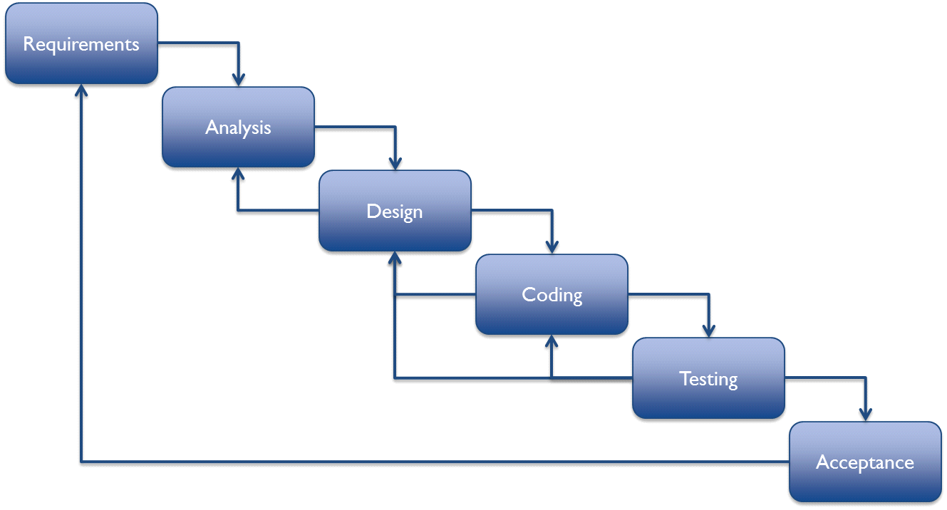

This diagram gives information about day scheduling information in our project.

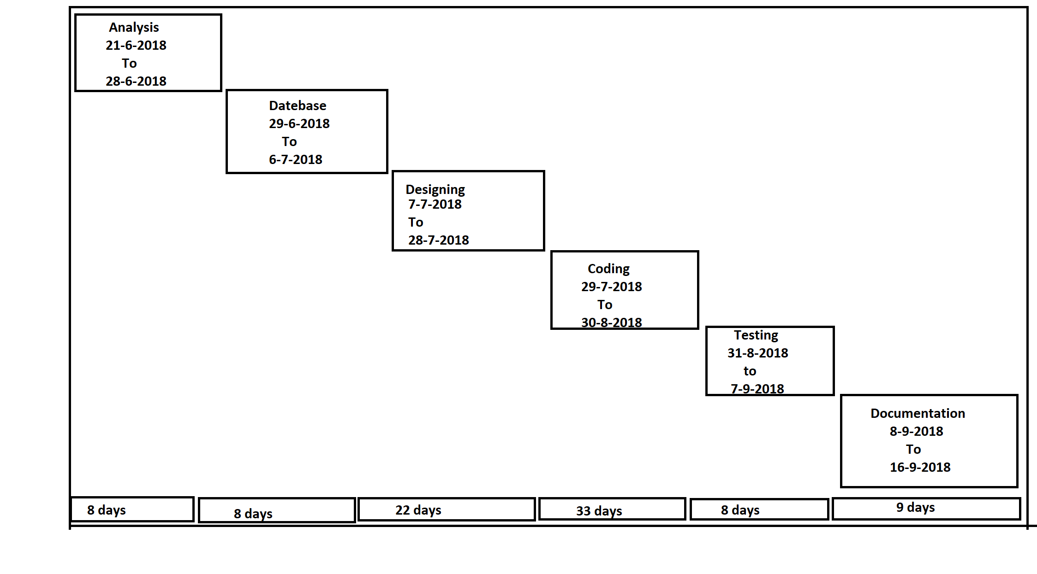

**Data Dictionary**

Data dictionary is the canter responsibility of information about system and Organization. Data dictionary contain a list of term and their meaning for all data items and data storages of the system.

:DATA TABLES:

* **Contact :**

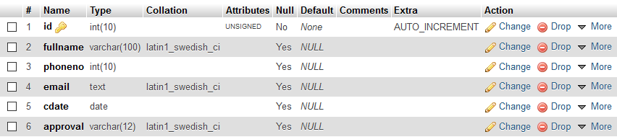

* **Login :**

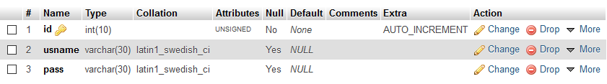

* **Newsletter log :**

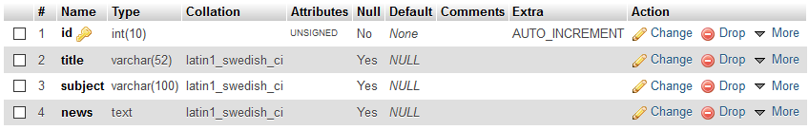

* **Payment :**

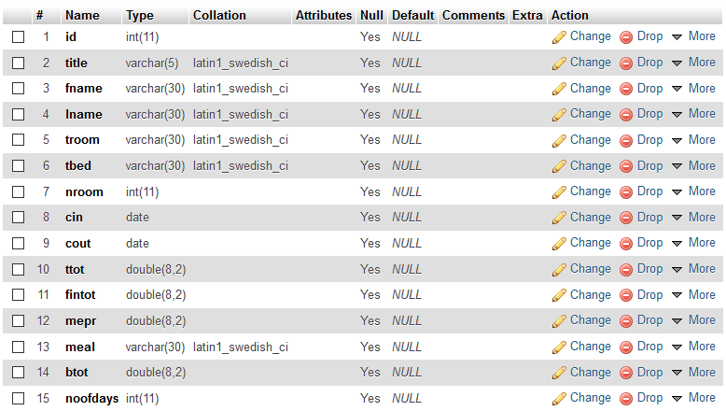

* **Room :**

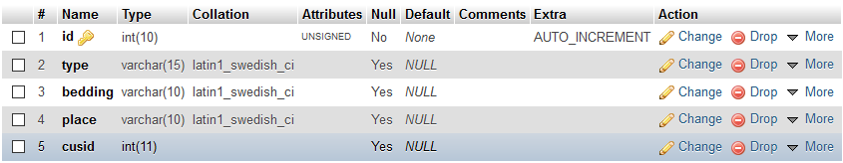

* **Roombook :**

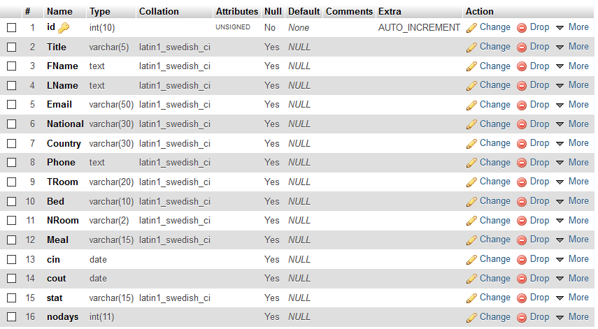

**Data Flow Diagram**

* Level DFD [client]**:-**

Home

Registartion

rre

Room

**Gallery**

**About us**

**Contact us**

**Banquets**

**Book now**

Level DFD [client]**:-**

**login**

**Roombook**

**User Panel Web-Page**

* Homepage ( index.php ) **:**-

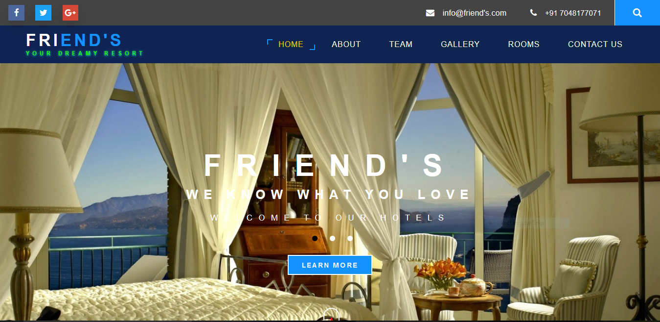

My project is one page project so all page link in home page. Client side is an important part of any project .

Home :-

This page is our main page for our clients.

About :-

It’s display our facility & information for clients.

Gallery :-

All-over hotel view pictures are capture in gallery.

Rooms:-

Rooms facility there are several types of rooms available such as deluxe , luxury , double & single clients can also book rooms from the site and our hotel rooms are very good .

Contact us:-

For contact our hotel.

Admin:-

For open admin panel. It can use only admin.

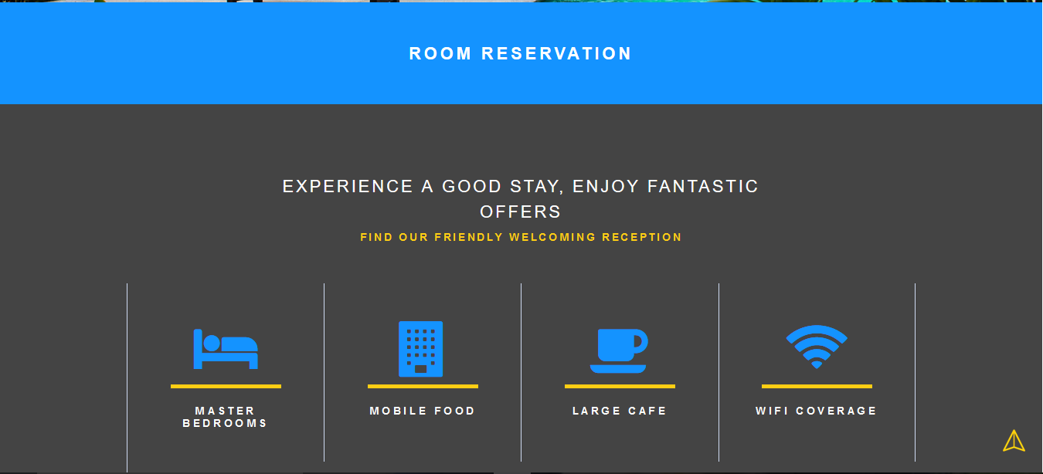

Room reservation:-

Click to room reservation to direct book rooms .

Our facilities:-

1. MASTER BEDROOMS

(2) MOBILE FOOD

(3) LARGE CAFÉ

(4) WIFI COVERAGE

* About **:**-

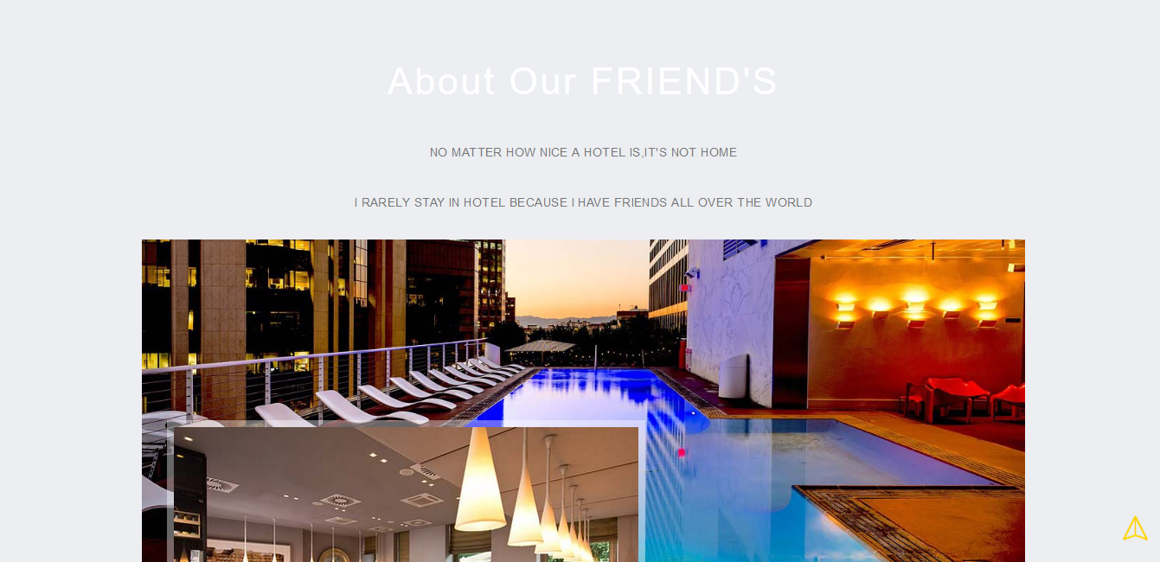

NO MATTER HOW NICE A HOTEL IS, IT'S NOT HOME I RARELY STAY IN HOTEL BECAUSE I HAVE FRIENDS ALL OVER THE WORLD .

It is display our hotel main points.



* Gallery **:**-

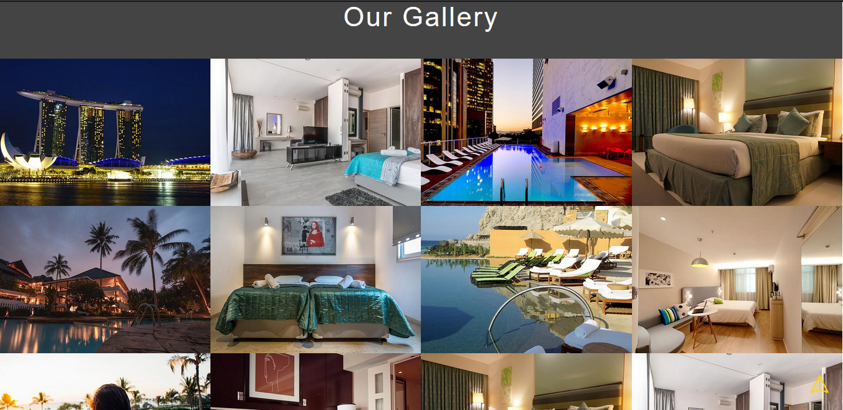

We display the all main part of hotel pictures . and facilities pictures. We can provide best facilities for our costumes.



* Rooms & Ratings **:**-

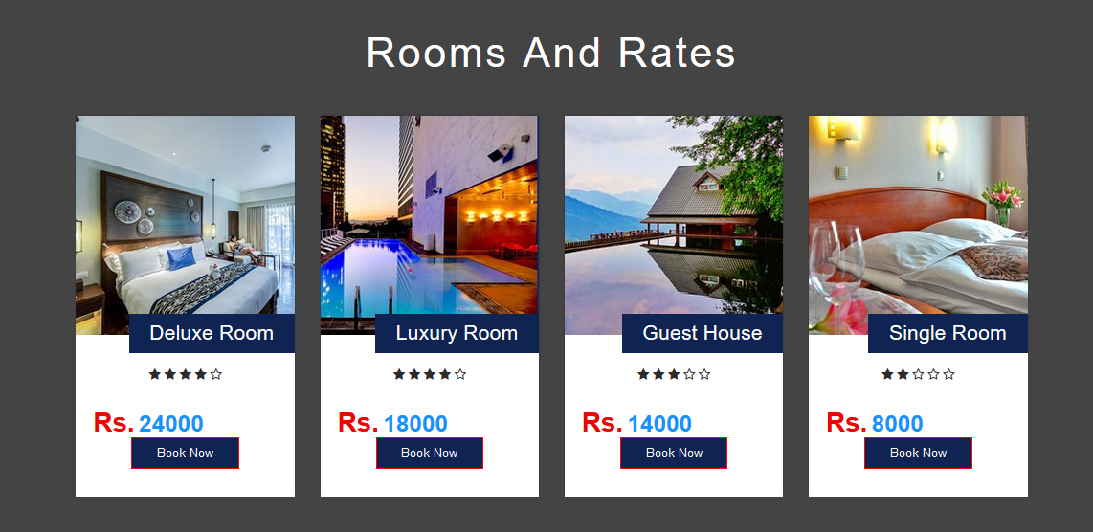

Costumers can online hotel room book for vacation. many types of rooms in our hotel. Like , deluxe, luxury, guest & single. Costumers are room booking if there needed.

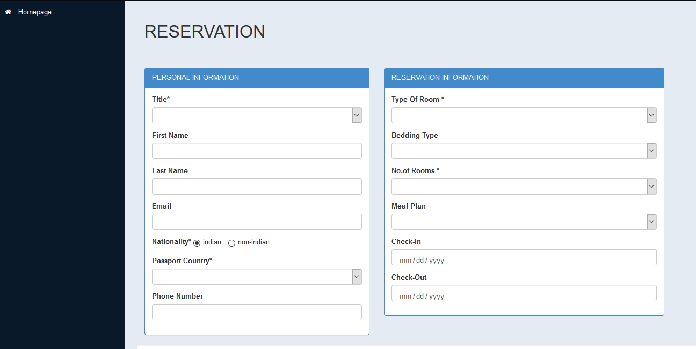

It is a reservation form for room booking . it is a very simple booking form for customers, so customers can easily book any room they are needed.

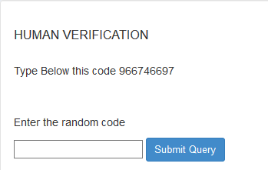

After a feel up reservation form site can send a human verification form and send a random code. Enter the random code click to submit query.

* Visitors experience :

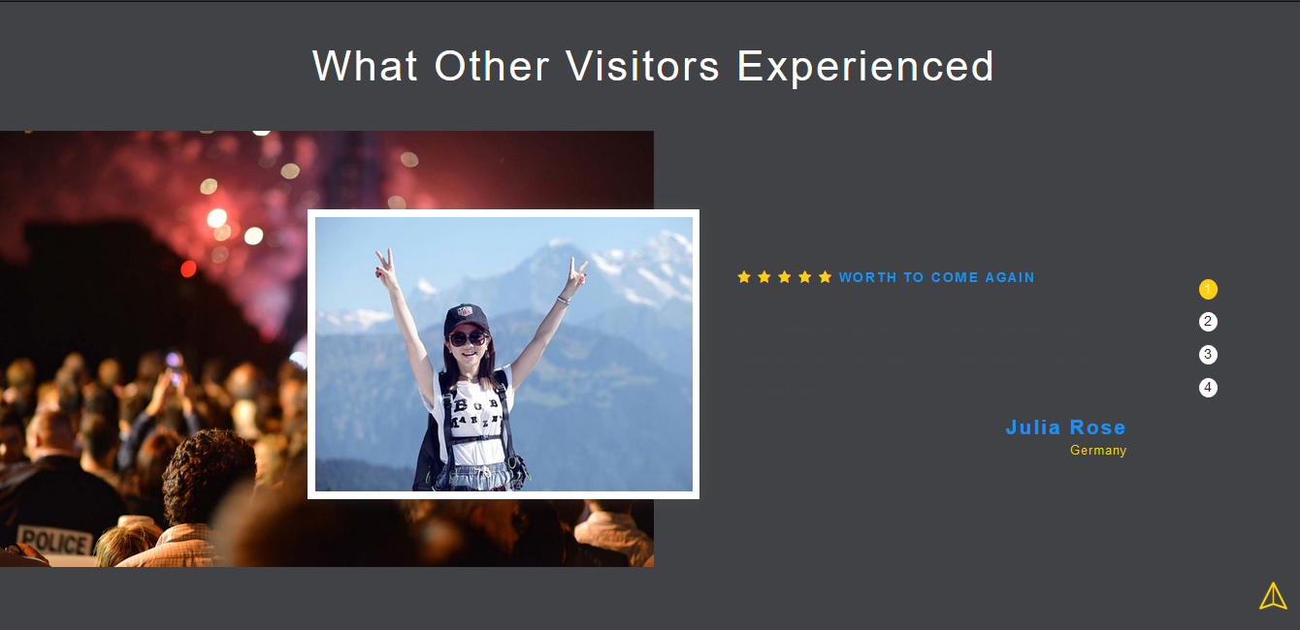

* Contact us :

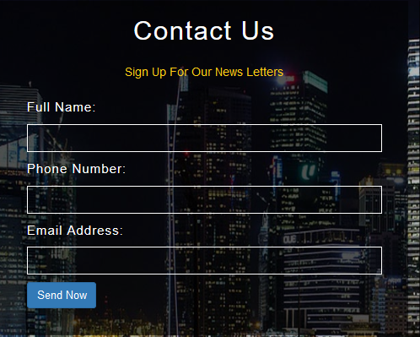

We can provide contact us page for contact to our hotel. Feel up the contact us form and click the submit button.

* Connect with us :

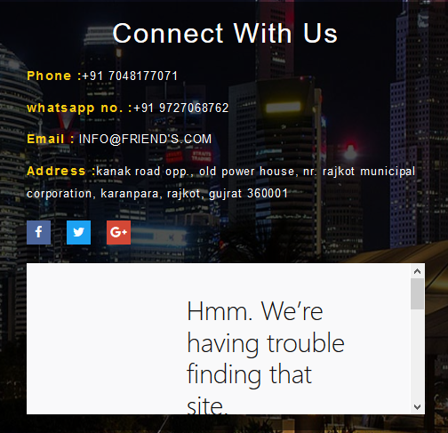

**Admin Panel Web-Pages**

* Admin Login( admin_login.php)**:**-

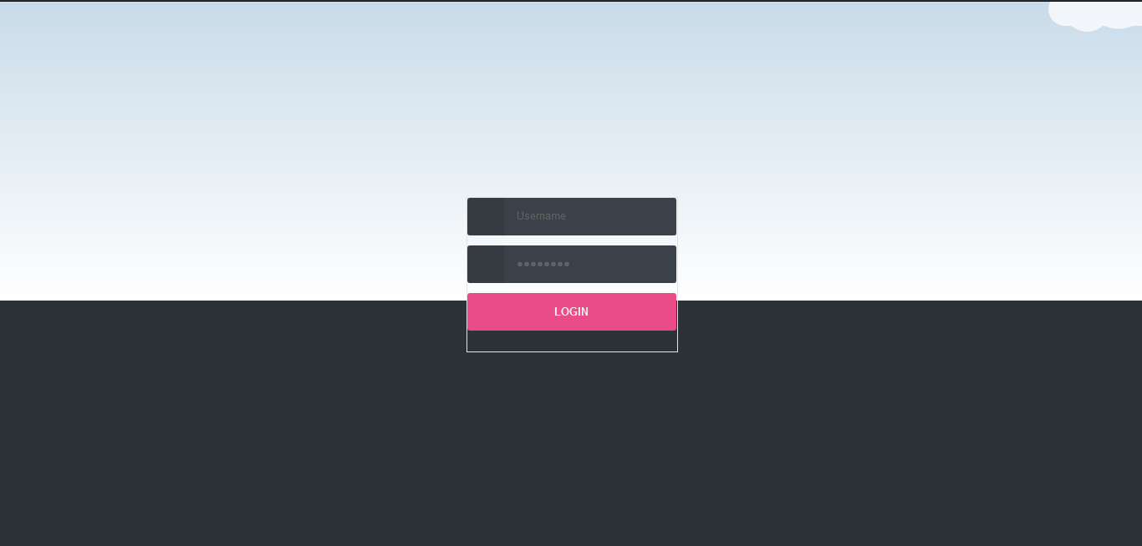

When we open an admin side we enter a user name and password but user name and password know only administrator so clients are not able to use admin site.

* Admin Dashboard **:**-

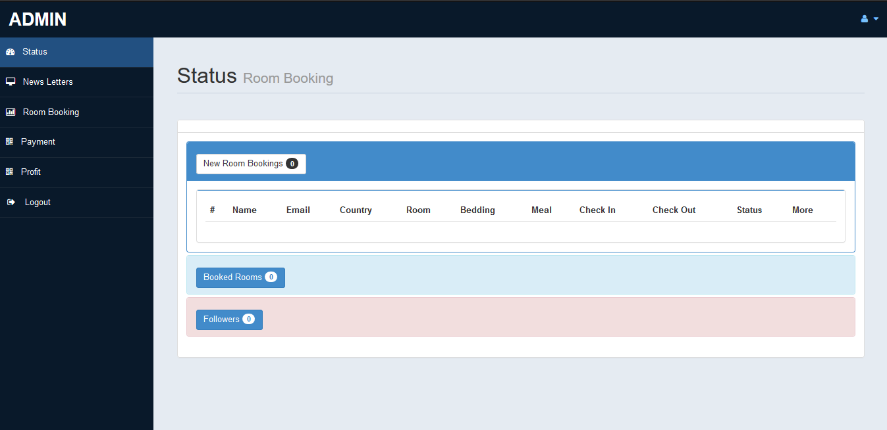

Status:- it’s display our new room bookings, clients information, booked rooms, flws.

Newsletters:- it is display our daily news. Server send daily news of hotel or other news send to clients.

Room booking:- it’s display our status of our rooms and rooms booking.

Payment:- it is show the payment of clients room’s , beds , meal , check in or out and many more.

Profit:- display profit of hotel.

Profile:- display profile of admins.

**About Testing**

This is the most crucial phase in the software development cycle. The developed application is thoroughly tested. Testing procedures and requirements differ with the nature of the product. It basically involves running through the whole application and verifying that the functionality is as per the designs.

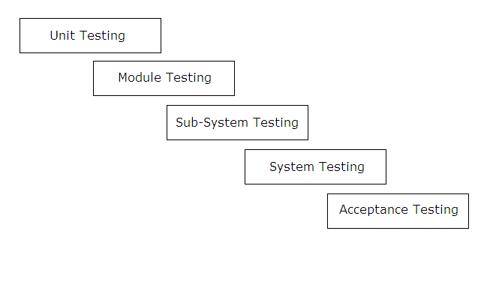

**Bibliography**

We are creating this project initial stage of out currier. To complete this project we refer many books and website to learn many topics. Those are very useful to create this project. We use following books and websites:

* **Books:-**
* Beginning PHP 5
* PHP manuals
* MYSQL manuals
* Practical HTML
* Dreamweaver MX
* HTML, CSS.
* **Websites:-**

**XAMPP:**http://www.apachefriends.org

**PHP:**http://www.php.net

**MySQL:**[http://www.mysql.com](http://www.mysql.com/)

